Module BC - Bootcamp

*Supervisor: Andrea Censi*

*Deadline: Friday Feb 19, 2016, 11:59pm*

Grading scheme: 100/15 points for each of the exercises.

Feedback and discussion about this module belong to the Slack channel #m01-BC-bootcamp (or comment directly here).

### **BC0: Enrollment and accounts**

(Most students should have already done this part.)

For the record, the main steps were:

1. Read carefully [the account guide](https://docs.google.com/document/d/1hIZftFCZEpcvL-yp8kkYMjWzGBiNcwajdn2_ZxeirIM/edit?usp=sharing).
2. Sign up to all services as instructed.
3. Submit the [Account Form.](http://goo.gl/forms/iPVNXOJmr6)

Wait for the Account Manager to contact you saying that everything is OK and you have all permissions.

To summarize, at this point you will have at least the following accounts:

* A Google Docs account, with appropriate permissions for the folder “Duckietown-engineering” (originally called just “Duckietown”) and “duckietown-public”
* A Dropbox account, with access to “Duckietown-data” and “Duckietown-media”.
* A Github account, with access to our organization “Duckietown”.
* A Slack account on the Duckietown-Engineers Slack.

### **BC1: Slack basics**

Subscribe to the channel #s-valeria. Send a nice greeting to our remote tester Valeria, who is 14 year old and lives in Alessandria, a city near Milan. She already built a robot with sonars driven by an Arduino. She has a Duckiebox kit (though not complete...) and she is trying to build a Duckiebot based on our instructions.

### **BC2: Duckiebox basics**

(Most students should have already done this part, as part of the first lab.)

Receive the Duckiebox and go through the checking out process, which involves editing the “What’s in the boxes?” spreadsheet.

Questions regarding this step should be directed to Misha (on Slack).

Desired final state: There is now a column in the “What’s in the boxes?” spreadsheet with your nickname, and the contents of the box reflect the spreadsheet column.

Furthermore, this invariant is preserved for the rest of the class.

### **BC3: Duckiebot construction**

(Most students have have already done this, as part of the first lab. Most others will be done on Tuesday.)

Build your robot according to instructions in the assembly guide.

Choose a name for your robot.

### **BC4: Duckiebot basic testing**

(12 students already did this)

Once the robot is completed, please contact Hang and undergo the testing procedure.

Desired final state: Hang agrees that your robot is fully functional.

Column H: put a checkmark if/when the robot has been tested.

### BC5: Checking permissions for Google Docs.

At this point you should have permissions to access all materials. For example, you should be able to edit this document.

Please add your nickname in this list: [Andrea, Liam, lapentab, Catherine, Victoria, Noam, Ari, Takke, Sam, Erlend, Tristan, Alex, Teddy, Joe, Mrinal, Amado, Nick, Jenny, Hans, Sang, Vero, Giulia, Abhi, Brandon, Yajun].

### BC6: Your Slack private channel

Create (if it doesn’t exist already) a hidden channel by the name “s-<nickname>” and add at least AC and LP.

**Update Feb 16: also Hang @zhao.**

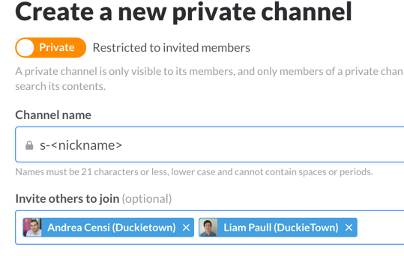

### BC7: Scuderia update

Update the spreadsheet “Scuderia” with your name and the robot name.

Column G: put a checkmark when assembly has been completed.

### **BC**8**: Duckiebox update exercise**

**It is now required that every Duckiebox contains 1 or more small size duckie.**

The small duckie looks like this:

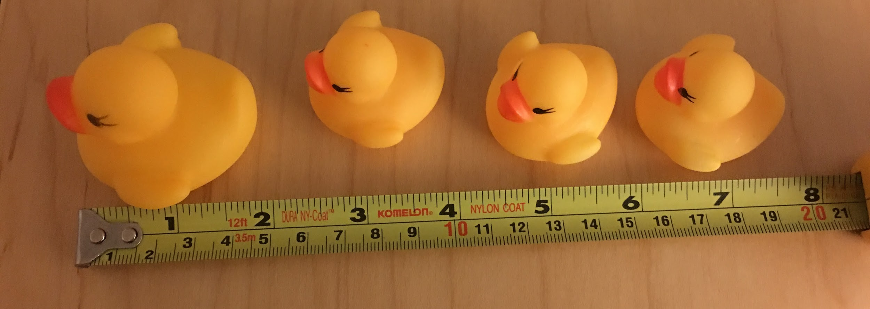

Please obtain one by the way this is supposed to be done, by asking on #equipment **and pin their request**.

**Update Feb 17: clarification about the steps needed to upgrade the duckiebox.**

1. **We tell you about the new item that needs to be in the box**
2. **You pin a message to #equipment**
3. **You schedule a meeting with an instructor / lab assistant, or swing by 226, or equipment is brought to class**
4. **The staff places the item in the duckiebox. Apart from emergencies, the staff can only give you an item if you have the duckiebox with you.**
5. **You update the row in the “what’s in the boxes?” spreadsheet.**
6. **You unpin the message from #equipment.**

### **BC**9**: Thank Sudeep for his patience**

Find Sudeep Pillai, who is usually ~~sitting~~ standing in 32-235, and tell him “Andrea is sorry we messed with your stuff in the rush for Friday’s lab”, and leave with him 1 regular duckie, plus one edible item of your choice. (Note: duckie and edible item should be handed to him personally. If he is not there you have to come back.)

Sudeep Pillai: 

Update “what’s in the box” spreadsheet accordingly to reflect the duckie donation.

(Optional) As you enter 32-235, say “Hi, Nira, how are you? Thanks for ordering all that stuff for the class.” to Nira, who might be sitting on the left.



### **BC**10**: Duckiebot configuration update exercise**

**It is now required that every Duckiebot has a regular size duckie safely secured on top.**

Please put a regular size duckie on your robot (clearly, a small size duckie is not old enough to drive). The duckie must be safely secured.

Convince one of the instructors to tell you “Wow, this is really cute”. (Instructors: please check that the duckie is safely secured.)

Post a picture of your robot on Slack (in the channel for this module, #m01-BC-bootcamp) with title “<instructor> told me this is cute enough”.

### **BC**11**: Github basics**

Follow the instructions in “Setup Step 1.9 - Github basics”. The end result is that you are able to modify a file in our repository, in the master branch.

### **BC**12**: Selfie with John**

Find John Leonard and take a picture with him and at least one duckie.

**(update Feb 15) Note: you, John Leonard, the duckie, the camera, must be at the same time in the same place. Finding a pictorial 2D representation of John Leonard and using it to take a “virtual selfie” is not allowed. Also, John Leonard must be aware that you are taking a picture with him, and looking at the camera and smiling.**

Post the picture in #cool-stuff. Put a copy in Dropbox:Duckietown-data/pictures.

Rules:

* It is forbidden to ask John for an appointment, via email or Slack.
* It is forbidden to knock at any closed door and disturb him while he is working. John can be asked only when he is in transit from one room to the next.

Hints:

* Ask the Keeper of the Gate, who is the person sitting just outside of 32-232, whether they can give you hints about John’s movements. Ask them about the technical solutions developed in the past to find John.

### BC13: Calendar usage - the most difficult part

Create an event “<nickname>’s birthday” in the Duckietown calendar, and invite Kirsten Bowser ([akbowser@gmail.com](mailto:akbowser@gmail.com)) , Andrea Censi (a.censi@gmail.com), and Liam Paull (liam.paull@gmail.com) by their gmail addresses.

### BC14: Confidential questionnaire

This questionnaire will be read only by Andrea. Feel free to submit this anonymously, or not.

<http://goo.gl/forms/vTmLWuLDTL>